Mental and Conceptual Models, Conceptualizing Interaction:
Activity 1: List and show screenshots of 10 mental models used in User Experience Design (UX).
- The first can be the recycle bin which can use used to delete or remove data from an app/workspace.

- The second is a most common hamburger menu, which is a kinda dropdown menu to save space on the page and have more elements. It is a common thing in apps that are large in functions as well as features. In the below image you can see how dropdown is used to tell different fonts as well as the type in those fonts.

- The interaction model is also a widely used experience design model where users expect actions to respond to their commands. One such example is zooming in and zooming out on a laptop as well as a mobile phone by pinching the fingers using either the trackpad or the screen of the phone.

- System feedback is a mental mode in ui/ux which is used to make the user aware that the system is loading right now. This is done by using spinners such as below.
- 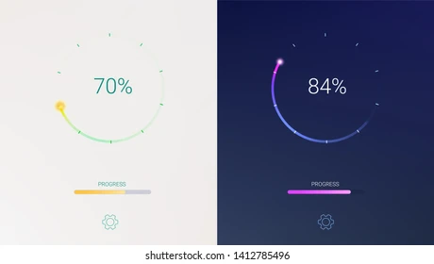

- The cross button or the close button is a basic indicator in any type of device be a mac, Windows, or Linux. This is given for the easyness of the user to quit or close a given application.
- Metaphorical mental models are often derived from real-life examples from an office, such as files, folders, and a desktop, to make the functionality of a os easy.
- Task-based mental model which enables the user to do a series of tasks, such as add items to the cart. This helps them come back to those items if they want to see the rate changes, or bulk order multiple items by paying once.



Activity 2: Explain the following Mental Models with clear examples:
a) First Principles Thinking
b) Second-order Thinking
c) Occam’s Razor
d) Compounding
e) Inversion
f) Confirmation Bias
Activity 3: Describe the components of the Conceptual Model underlying most online shopping websites, for example, Shopping cart, Proceeding to check-out, Payment, etc
Divide the components into:
1. Domain objects
2. Tasks/operations
3. Interface metaphors
Compare the online shopping experience with the physical shopping experience at a store. What all activities that can take place at a physical store are also possible at an online shopping website and what are not?
Draw the conceptual model above using an appropriate diagram type.

